Low-Cost Offline Voice Assistant for
Hospitality Services in Sri Lanka Using
Small-Scale Neural Models

Introduction
The hospitality industry in Sri Lanka is a key contributor to the national economy, with hotels continuously seeking ways to enhance the guest experience while managing operational costs. Traditional room service communication methods such as telephone calls to the front desk or physical service request forms are often inefficient, prone to miscommunication, and depend on dedicated staff availability. As a result, guest request handling suffers from delays, a lack of accountability, and poor service traceability.
Recent advancements in speech recognition and natural language processing (NLP) have produced commercial voice assistant solutions such as Amazon Alexa for Hospitality and Google Nest for Hotels. However, these systems rely heavily on cloud infrastructure, require continuous internet connectivity, and raise significant data privacy concerns for hotel guests. Furthermore, their high costs including proprietary hardware and recurring cloud API subscriptions render them impractical for hotels in developing countries such as Sri Lanka.
This research proposes a low-cost, offline-capable voice assistant system designed specifically for hotel room service operations. Named ‘Sera’, the system leverages small-scale neural models running on commodity Android devices to provide speech-to-text (STT), intent classification, and text-to-speech (TTS) capabilities operating entirely on-device or within a local network, without any dependency on external cloud services. Guests make service requests through natural voice commands, which are automatically classified, routed to the appropriate hotel department, and tracked in real-time through a web-based staff dashboard.

Problem Statement
Hotels in Sri Lanka and similar developing economies face several challenges in modernizing their guest service operations. Existing commercial voice assistant systems are built upon cloud-dependent architectures that incur recurring subscription fees, require proprietary hardware, and transmit guest voice data to external servers raising both economic and privacy barriers to adoption.
Traditional room service communication primarily telephone-based suffers from language barriers, long wait times, and an absence of systematic request tracking, making quality assurance difficult. Furthermore, existing voice assistants are primarily optimized for native English speakers, producing significantly degraded performance with other accents common among both local staff and international guests in Sri Lanka.
Research Question: How effective is a commodity hardware-based, offline voice assistant system at reducing operational inefficiency and improving service quality compared to traditional room service methods in Sri Lankan hotels?
This research aims to design, develop, and evaluate an integrated offline voice assistant system that operates entirely within a hotel's local network using commodity Android devices, small-scale on-device neural models, and a real-time hotel management backend without any cloud dependency.
Objectives
Design, develop, and evaluate a low-cost, privacy-preserving offline voice assistant system for hotel room service operations that is deployable on commodity Android hardware.
- Design and implement on-device speech-to-text (STT) using Vosk and on-device intent classification using a fine-tuned MobileBERT model converted to TensorFlow Lite
- Create a hotel-specific intent classification dataset covering most common service request categories
- Build a real-time hotel management backend with automated department routing and a web-based staff dashboard for request tracking and bidirectional communication
- Implement voice-based interaction for the complete request lifecycle, including submission, confirmation, cancellation, and service rating
- Evaluate the edge system's intent classification accuracy, end-to-end latency, and cost-effectiveness compared to cloud/on-prem server based alternatives
- Demonstrate a privacy-preserving edge computing architecture for hospitality AI with no external voice data transmission

Literature Review
The adoption of voice assistants in the hospitality industry has gained significant momentum, with major hotel chains deploying Amazon Alexa for Hospitality and Google Nest Hub. Research by Buhalis and Moldavska (2022) highlighted that while AI-powered voice assistants improve guest satisfaction and operational efficiency, privacy concerns remain a significant barrier to adoption, with 67% of hotel guests expressing discomfort with cloud-connected microphones in their rooms. These commercial deployments require continuous cloud connectivity and incur ongoing API costs limitations that are especially prohibitive for hotels in developing economies.
Offline Speech Recognition has advanced considerably with models such as Vosk (Alpha Cephei, 2020), providing lightweight, offline-capable speech recognition suitable for privacy-sensitive applications. Korkmaz et al. (2025) demonstrated deployment of Vosk-based STT on edge hardware with ultra-low latency, validating its suitability for real-time applications. OpenAI Whisper (Radford et al., 2023) achieves state-of-the-art accuracy but requires significant computational resources, making it unsuitable for on-device deployment on commodity Android hardware.
Small-Scale NLU Models have enabled on-device natural language understanding through knowledge distillation. MobileBERT (Sun et al., 2020) achieves 4.3x compression and 5.5x speedup over BERT-Base while retaining 96% of its performance, and is deployable via TensorFlow Lite on mobile devices. DistilBERT (Sanh et al., 2019) similarly retains 97% of BERT's accuracy at 40% smaller size. Bujel et al. (2021) demonstrated that fine-tuning BERT variants with approximately 1,000 labelled examples per class achieves strong intent classification accuracy on domain-specific datasets, validating the feasibility of hotel-specific NLU training with limited data.
Edge Computing and Privacy-Preserving AI form a critical theoretical foundation for this research. Shi et al. (2016) established the framework for edge intelligence, demonstrating that processing data locally at the network edge reduces both latency and privacy risks. Privacy vulnerabilities in hotel Alexa deployments have been documented (Purdue University, 2018), reinforcing the need for local-processing alternatives. Recent work on privacy-preserving on-device speech recognition (2025) demonstrated that custom Vosk models can outperform cloud STT with a 40% Word Error Rate (WER) reduction while processing all audio locally.
Task-Oriented Dialogue Systems for domain-specific applications have been surveyed extensively (Larson et al., 2022), identifying a critical gap in hospitality-specific datasets and on-device intent classification pipelines. Rasa's DIET architecture (Bunk et al., 2020) provides server-side intent classification but does not support on-device mobile inference. No existing published work combines offline STT, on-device NLU, and a real-time hotel management backend into a single integrated system for hospitality operations.

Research Gap: While individual components offline STT, mobile NLU, and hotel management systems exist in isolation, no published research combines them into an integrated, low-cost, offline-capable voice assistant specifically designed for hospitality services in developing economies. This research addresses this gap by providing a complete end-to-end system operating entirely within a hotel's local network on commodity hardware.
Methodology
The following methodology has been identified for this research:
- Comprehensive Literature Review Conduct a complete review of existing research on voice assistants in hospitality, offline speech recognition, small-scale neural models, edge computing, and privacy-preserving AI.
  - Voice Assistants in Hospitality: commercial deployments and guest experience research
  - Offline and Edge-Based Speech Recognition Systems
  - Small-Scale NLU Models for Resource-Constrained Devices
  - Privacy-Preserving AI and Edge Computing Architectures
  - Task-Oriented Dialogue Systems and Intent Classification
  - Sri Lankan hospitality industry context and digital readiness
- Problem Definition and Dataset Preparation Define system requirements based on the operational needs of Sri Lankan hotels and create a domain-specific training dataset.
  - Identify the most common hotel service request intent categories
  - Curate approximately 5,000 labelled natural language examples with colloquial and accent-influenced variations
  - Apply stratified splitting (85% training / 15% validation) for balanced class representation
  - Augment training data with paraphrasing and synonym replacement to improve generalization
- Model Development and Training Develop and train the on-device speech and language understanding components.
  - Deploy Vosk offline STT (vosk-model-en-in-0.22, 205MB) with custom Voice Activity Detection
  - Fine-tune MobileBERT (google/mobilebert-uncased) on the hotel intent dataset using AdamW optimiser
  - Convert the trained model to TensorFlow Lite format for on-device Android inference
  - Implement a hybrid classification pipeline: Rule-based keyword matching (Tier 1, confidence 0.99) + MobileBERT inference (Tier 2) with a minimum confidence threshold of 0.60
- System Development Design and implement the complete end-to-end system prototype across three components:
  - Android Application (Guest Device): Kotlin with Jetpack Compose; on-device STT and NLU; voice confirmation, cancellation, and rating; real-time WebSocket status updates
  - Backend Server: FastAPI (Python) with SQLite; RESTful API for request lifecycle management; WebSocket hub for real-time bidirectional communication; automatic intent-to-department routing across 5 departments
  - Staff Dashboard: Single-page web application; department-specific request queues; status management; staff-to-guest messaging; browser desktop notifications; live WebSocket connection status
- Evaluation Metrics and Testing Evaluate the system across model performance, system performance, cost, and user dimensions.
  - Quantitative Analysis
    - NLU Intent Accuracy
    - STT Word Error Rate (WER) benchmark on hotel-domain speech
    - End-to-end latency measurement per pipeline stage
  - System Performance Analysis
    - CPU and memory consumption on commodity Android devices at varying price points
    - Cost-per-request comparison against cloud-based alternatives (Alexa, Google, Dialogflow - research based)
High-Level System Conceptual View
The system operates across three distinct layers connected via a local Wi-Fi network within the hotel premises. No external internet connection is required for core operations. All AI processing occurs on the guest device. The server handles only coordination and persistence.
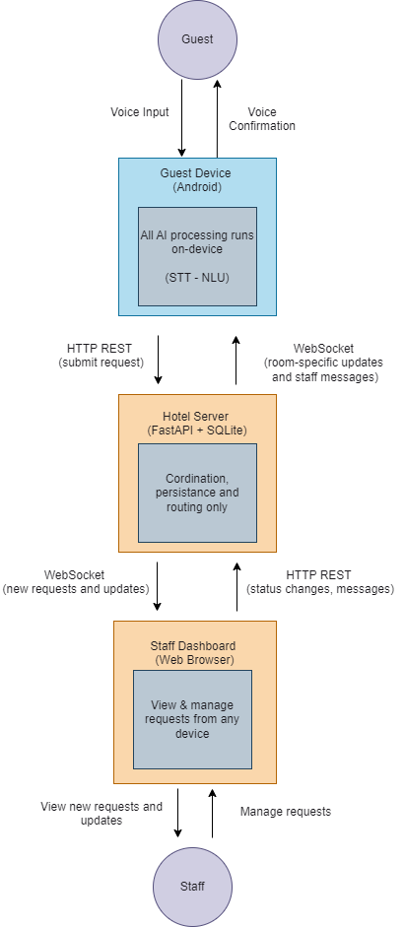

Timeline
Activity | Start | End | How scaled
Literature Review | Oct 01 | Oct 28 | W1–3 → 4 weeks
Dataset Preparation | Oct 15 | Nov 11 | W3–5 → 4 weeks (overlaps Ph1 end)
Model Training | Nov 05 | Dec 02 | W5–8 → 4 weeks
Android App | Nov 19 | Dec 23 | W6–10 → 5 weeks
Backend API | Nov 26 | Dec 23 | W7–10 → 4 weeks
Staff Dashboard | Dec 10 | Jan 06 | W9–11 → 4 weeks
Integration & Testing | Dec 31 | Jan 27 | W11–13 → 4 weeks
Evaluation | Jan 14 | Feb 10 | W13–15 → 4 weeks (overlaps integration end)
Thesis Writing | Jan 28 | Mar 10 | W14–18 → 6 weeks
Final Review & Submission | Mar 04 | Mar 31 | W18–20 → 4 weeks

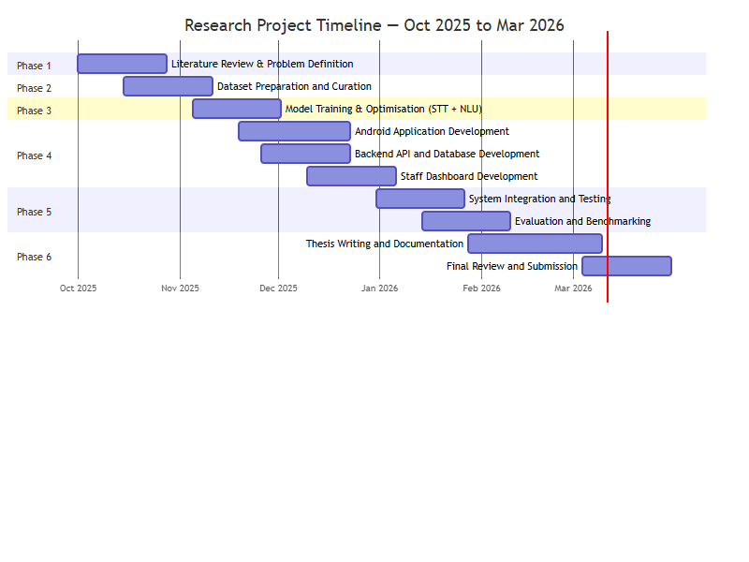

Expected Outcome
- A Working System Prototype: A fully functional offline voice assistant deployable on commodity Android devices, capable of processing hotel service requests end-to-end without cloud connectivity, comprising an Android guest app, a FastAPI backend, and a web-based staff dashboard.
- A Hotel-Specific Intent Dataset: Approximately 5,000 labelled natural language examples across most common hotel service request categories, representing the first publicly documentable dataset of this kind for Sri Lankan hospitality NLU.
- A Fine-Tuned On-Device NLU Model: A MobileBERT model fine-tuned on hotel service data, achieving greater than 90% intent classification accuracy, converted to TensorFlow Lite format for on-device inference on commodity Android hardware.
- Performance Evaluation: Benchmarked STT Word Error Rate on hotel-domain speech, end-to-end latency measurements, and cost-per-request comparison against commercial cloud-based voice assistant alternatives.
- A Privacy-Preserving Architecture: Demonstrated architectural proof that all guest voice data is processed locally on the Android device, with no audio or speech data transmitted to external servers, providing a GDPR-compatible deployment model for hotels serving international guests.

Conclusion
This research aims to address a critical gap at the intersection of edge AI, privacy-preserving computing, and hospitality technology by developing a low-cost, offline-capable voice assistant system tailored for hotel room service operations in Sri Lanka. By leveraging small-scale neural models Vosk for on-device speech recognition and MobileBERT for intent classification running on commodity Android hardware, the system eliminates dependency on expensive cloud services and proprietary devices, while preserving guest privacy through local-only data processing.
The proposed system demonstrates that effective voice-based hotel service automation is achievable without cloud connectivity, using hardware costing a fraction of commercial alternatives. The real-time WebSocket architecture ensures seamless bidirectional communication between guest devices, the hotel management backend, and staff dashboards, enabling complete request lifecycle management including voice confirmation, cancellation, and service rating. This research offers a replicable, practically deployable model for hotels in developing economies seeking to modernize guest services without expensive infrastructure investments.

References
Alpha Cephei. (2020). Vosk Offline Speech Recognition API. https://alphacephei.com/vosk/
Buhalis, D. & Moldavska, I. (2021). In-room Voice-Based AI Digital Assistants Transforming On-Site Hotel Services and Guests' Experiences. In Information and Communication Technologies in Tourism 2021. Springer.
Buhalis, D. & Moldavska, I. (2022). Voice Assistants in Hospitality: Using Artificial Intelligence for Customer Service. Journal of Hospitality and Tourism Technology, 13(3), 386–403.
Bujel, K., Laffy, J. & Kochenderfer, M. (2021). Effectiveness of Pre-training for Few-shot Intent Classification. arXiv:2109.05782.
Bunk, T. et al. (2020). DIET: Dual Intent and Entity Transformer. Rasa Technologies.
Chantrapornchai, C. & Suchato, A. (2022). IoT Device Control with Offline Automatic Speech Recognition on Edge Device. IEEE Conference Publication.
Hwang, J. & Erdem, M. (2025). "U" in User Experience (UX) Stands for the Frontline Employee: A Case Study of Voice Assistant Technology Use in Hotels. Journal of Hospitality & Tourism Cases.
Korkmaz, A. et al. (2025). Real-Time Speech-to-Text on Edge: A Prototype System for Ultra-Low Latency Communication with AI-Powered NLP. Information, 16(8), 685.
Larson, S. et al. (2022). A Survey of Intent Classification and Slot-Filling Datasets for Task-Oriented Dialog. arXiv:2207.13211.
Purdue University. (2018). Amazon Alexa Devices in Hotels Raise Privacy Concerns. Purdue University Newsroom.
Radford, A. et al. (2023). Robust Speech Recognition via Large-Scale Weak Supervision (Whisper). ICML 2023.
Sanh, V. et al. (2019). DistilBERT, a Distilled Version of BERT: Smaller, Faster, Cheaper and Lighter. NeurIPS 2019 Workshop.
Shi, W. et al. (2016). Edge Computing: Vision and Challenges. IEEE Internet of Things Journal, 3(5), 637–646.
Sun, Z. et al. (2020). MobileBERT: a Compact Task-Agnostic BERT for Resource-Limited Devices. ACL 2020.

